**Practical Test: Railway Reservation**

1. The website has information regarding the passengers and the trains. It has three pages: home, passengers information and trains information namely
2. Home Page: it has carousal for the images and cards has been implemented to provide the features or services.

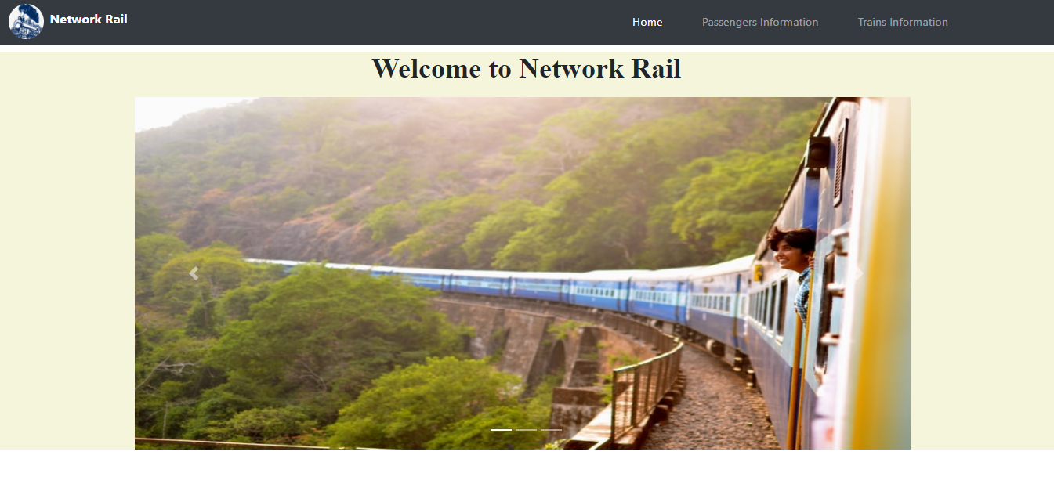

Corousal Image 1

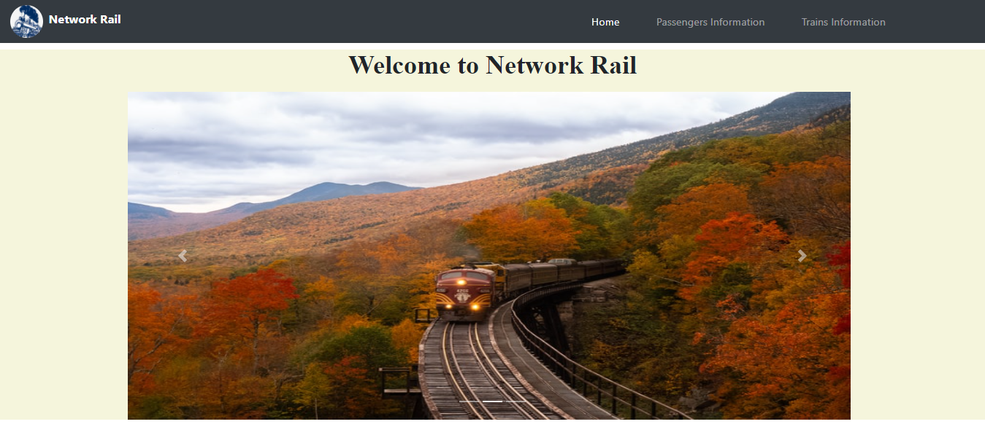

Corousal image 2

1. Services Section: with information about various services.

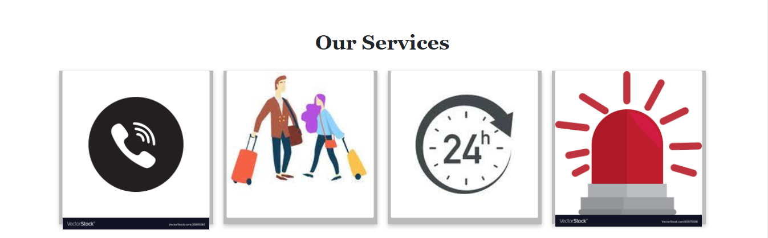

Services section

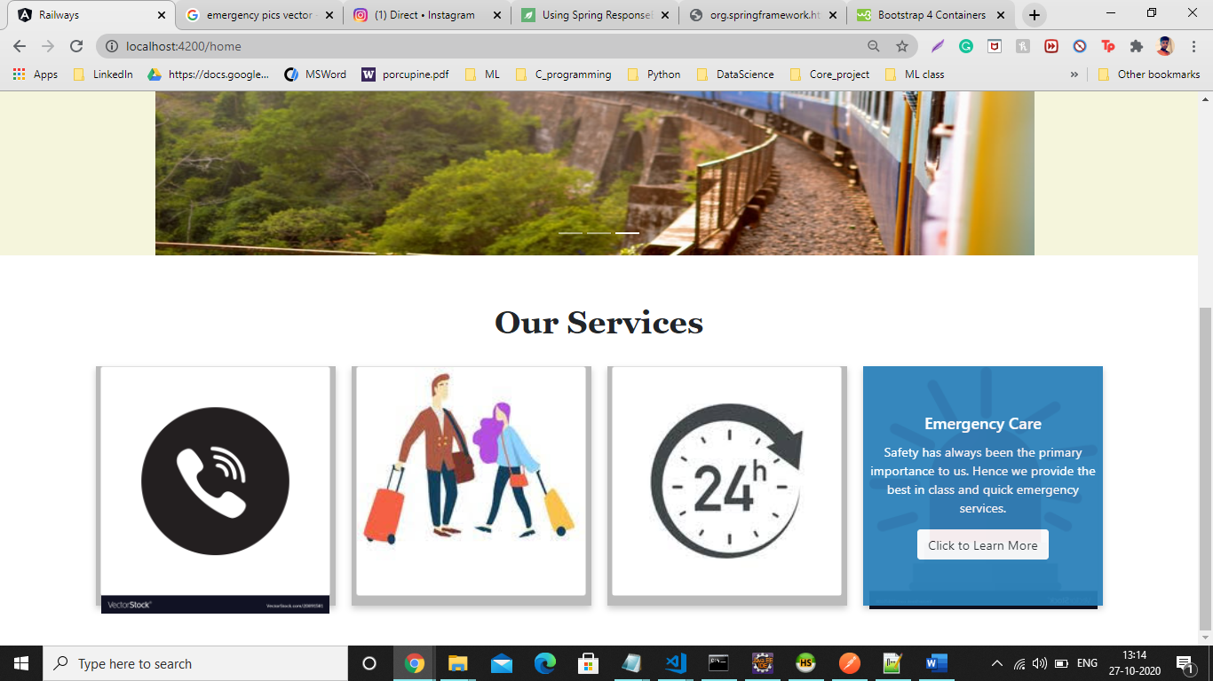

Services section with flip card

1. Navigation Bar – Which helps us route for different pages.



On click on Network Rail and Home routes to home and others routes to their respective components

1. Passengers Information – This page has the information about the passengers in the table form.

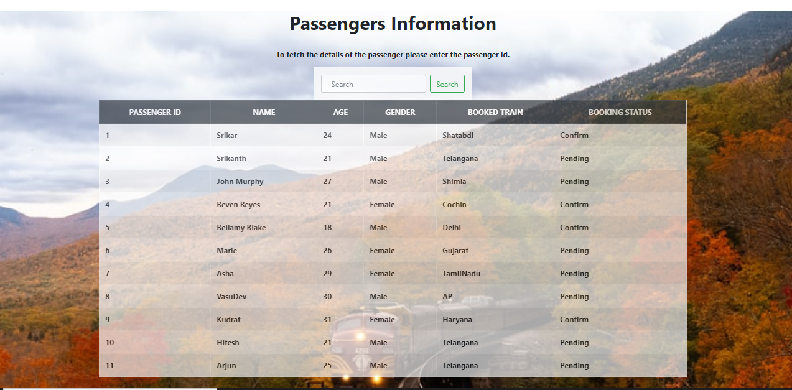

Passenger’s information

1. Selected Passenger information – On providing the passengers Id we get the information.

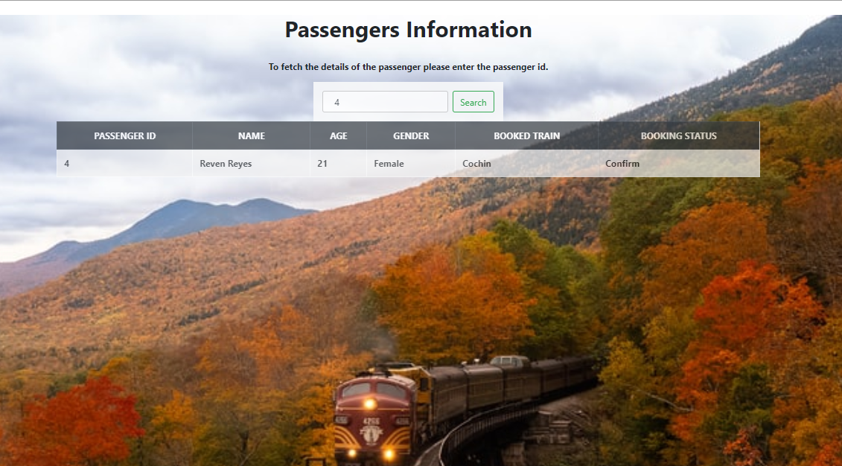

Selected passenger information

1. Trains Information – The page contains the information about all the trains.

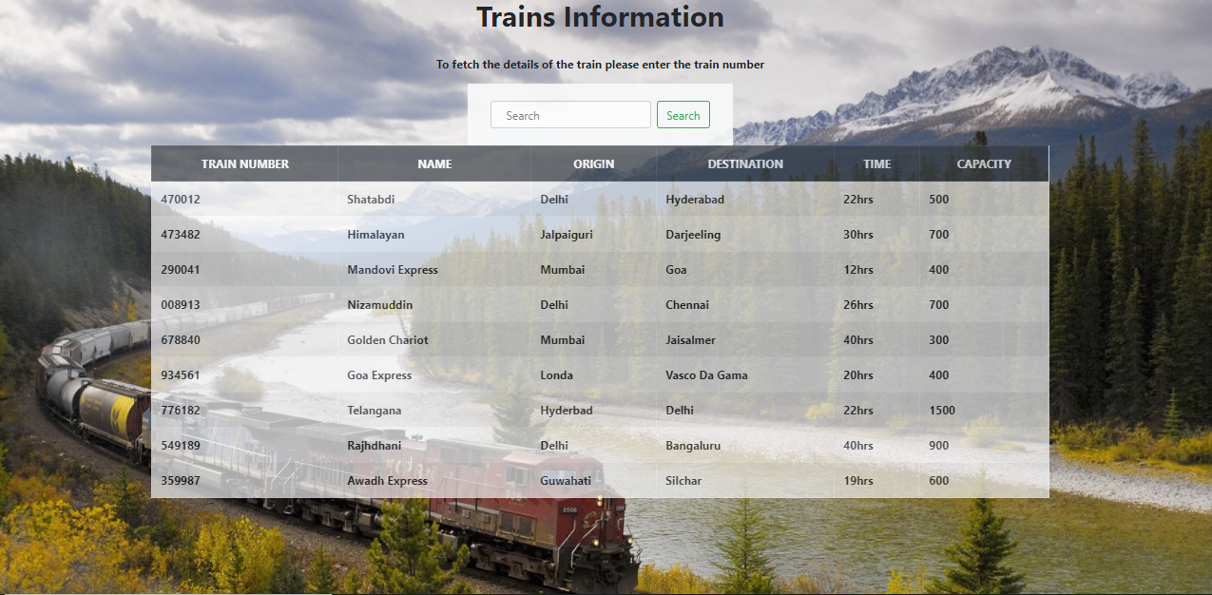

Trains Information

1. Selected Trains Information – On search using the specific train number, we do get the trains data.

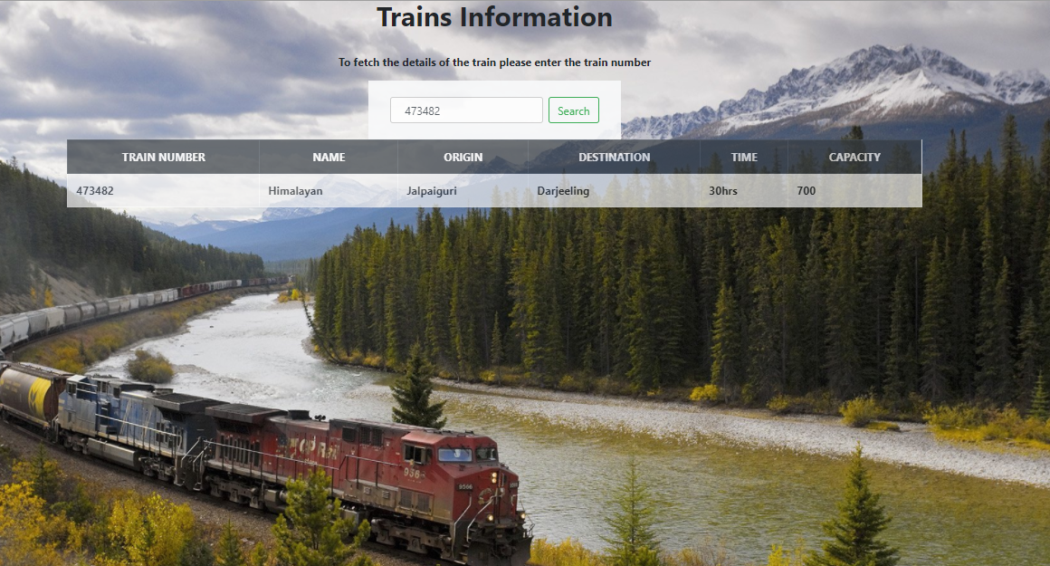

On selected user train data.

**Thank you**